Report PL/SQL Techniques

by Aliaksandr Labayeu

# Model of DWH layer

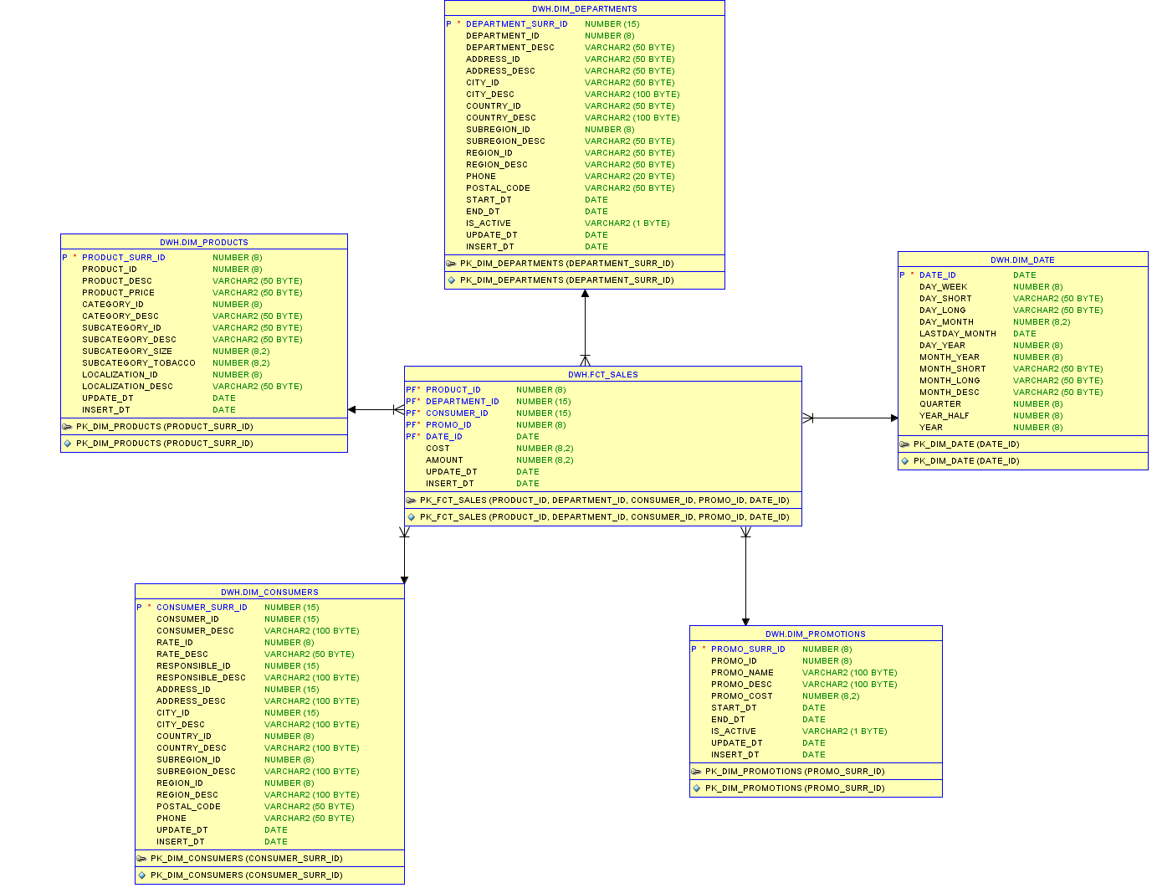

# Contributing data to DWH layer

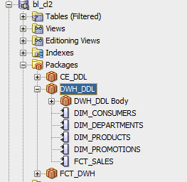

All DML operations of merging data are performed in one package “DWH_DDL”

Every procedure is a merge statement that provide updating or inserting data if it not matched with the data from CLS2 lvl

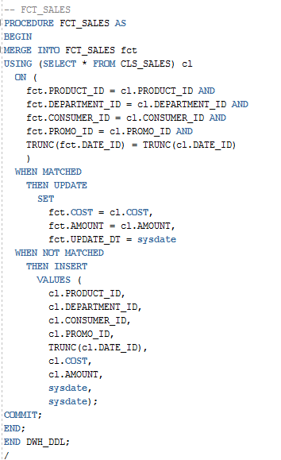

# Other PL/SQL features

## Cursor FOR loop

Cursor FOR LOOP is used to insert data in CLS tables from WORK tables. It is not the best way to use CURSOR in INSERT statement because of long time of executing, but if the talk goes about non-huge table like CLS_PRODUCTS it will not cause much time executing.

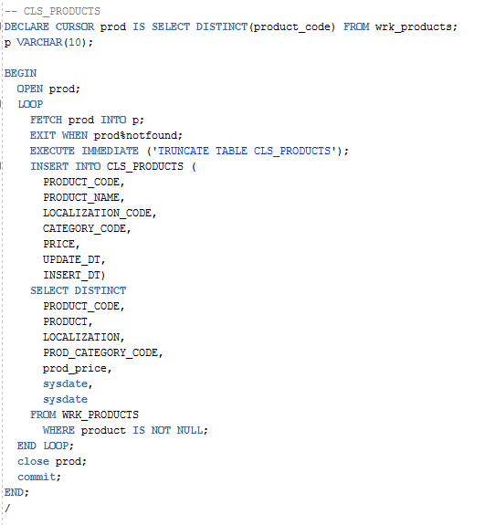

## Bulk Collet + FORALL + EXECUTE IMMEDIATE

Bulk collect with FORALL makes it possible to INSERT multiple rows in one time, that makes INSERT much faster than INSERT with Cursor statement.

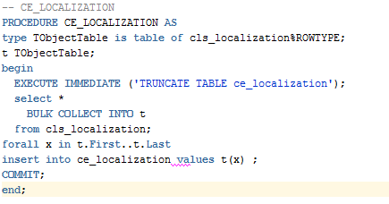

* file with package and procedure can be found in file “pkg_CE_DDL.sql”